QYE101R1B8 Industrial Tablet
Specifications
Ver.#: 1.0
2022.06

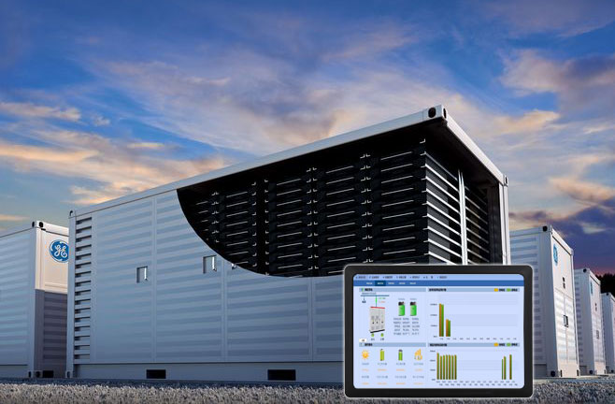

QIYANG TECHNOLOGY Co., Ltd
Copyright Reserved

Technical Support
If you have questions about the documents, you can contact us during office hours (Monday to Friday 8:30-12:00, 13:30-17:30)
Contact us at
Technical Email：supports@qiyangtech.com
Technical Support Telephone No.：0571-87858811-805
Official website：www.qiytech.com(Chinese）/www.qiyangtech.com(English）

Information updates
1. Information updates
Product-related manuals and datasheets are constantly being improved and updated; please ensure that they are up-to-date when you use them.
2.Update notice
Qiyang’s newest product information and news updates will be released through the WeChat official account, please pay attention!
3.How to get information
After purchase, please contact the relevant sales staff to obtain the SDK.

Version Record
Version | Hardware Platform | Description | Date | Revisor
1.0 |  | First release | 2023-06

Contents
Contents
Ⅰ. Preface 1
1.1.Company Profile 1
1.2. Use Suggestion 1
Ⅱ. Appearance 2
Ⅲ. Parameters 3
Ⅳ. Structure &Size 5
Ⅴ. Pin Definition 6
Ⅵ.Installation Methods 9
Ⅶ. Shipping List 10
Ⅷ. Cautions 11

Notice: This manual introduces the hardware interface of the QYE101R1B8 Industrial Tablet.

Ⅰ. Preface

1.1.Company Profile
Zhejiang Qiyang Intelligent Technology Co., Ltd., established in 2007, which locates in Hangzhou, Zhejiang, PRC. It is a high-end technological enterprise that specializes in exploitation, fabrication, and selling embedded computer mainboards . With 10 years of experiences, Qiyang has established the completed service chain from the design concept to mass production successfully.
The R&D team is organized by 30 more technical engineers. Qiyang focus on providing functional embedded hardware, software tool and customization solutions. It has been applied to Industrial Control, Internet of Things, New Retail, Smart Medical, Electricity Device, Environmental Surveillance, Charging Pile etc.
With the growth of the business, Qiyang has set up an SMT factory in Zhuji, Zhejiang province, which is 5000㎡, with a 2xSMT production line. The SMT factory performs the ISO9001 Quality Management System strictly. Relying on the solid production ability, the SMT factory’s annual capacity is about a million sets, which totally guarantee the delivery date.
Qiyang has a thorough sales marketing network, professional sales ,and after-sales team to provide full technical support and service. The business has spread over 120 countries and areas, it helps the clients to introduce the products into the market efficiently and successfully.The combination and extension of research and development, production capacity, and market, that provide a solid foundation for Qiyang to provide specialized, globalized embedded hardware and software.
We offer:
l.Software/Hardware Mainboard
Based on the CPU solution from NXP,Rockchip,MTK,Renesas,TI,Atmel,Cirrus Logic etc, Qiyang provides the ARM development kit/system on module/industrial board and periphery products, paired tools and software for the user do further exploitation.
2.Customization Service
Fully taking the advantage of the technical accumulation on the ARM platform and Linux, Android, Ubuntu OS, Qiyang provides the efficient OEM/ODM service to the users.

Sincerely thanks for using Qiyang’s product, we will try our best to offer you the technical supports!

1.2. Use Suggestion
1)Please read this manual before using.
2)Please check the packing list, and accessories to ensure there is no missing;
3)Understand basic structure and composition of the products, including the hardware parameters, etc.

Ⅱ. Appearance
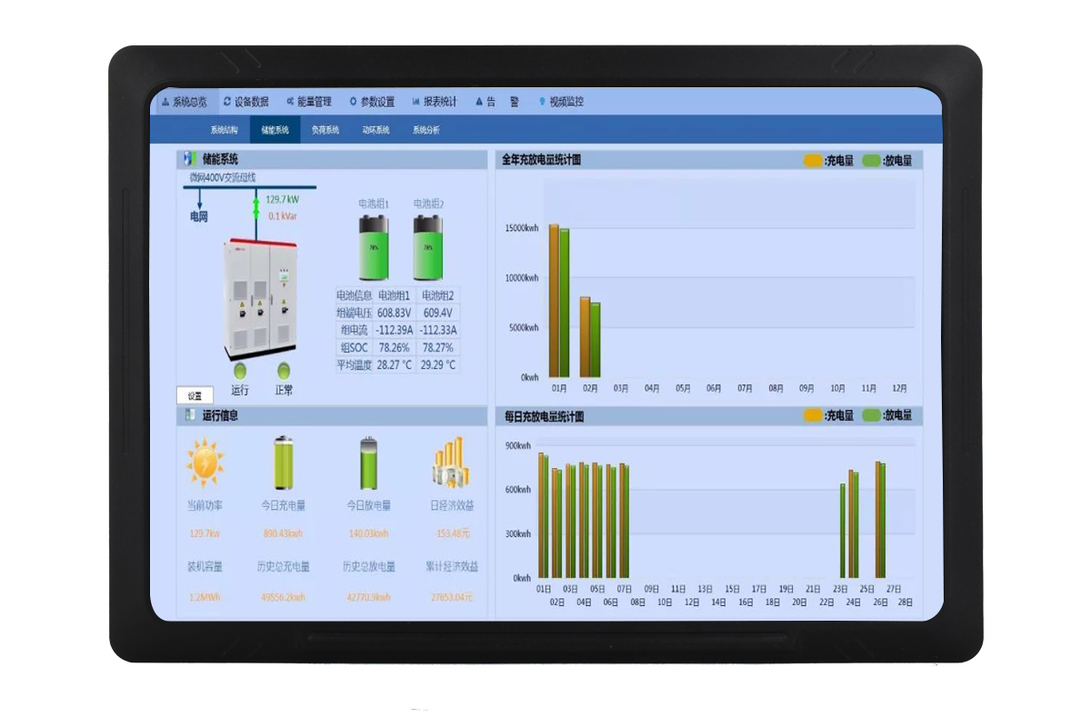
Front Side

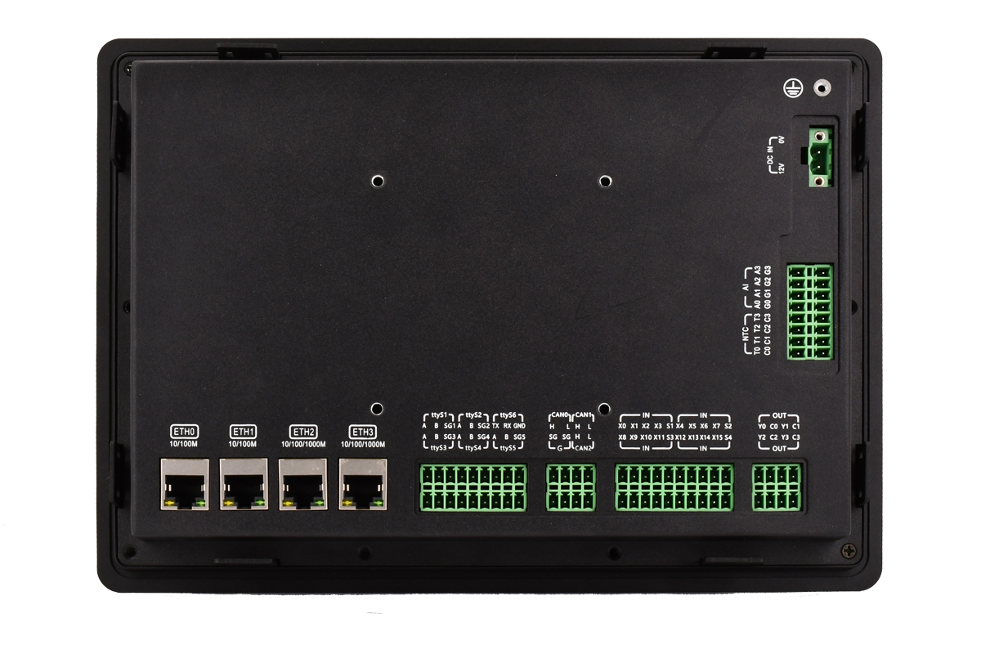
Back Side

Ⅲ. Parameters
Screen | Size | 10.1 inch, full view
 | Resolution | 1280*800
 | Brightness | 350 CD/M²
 | Touch Panel | Resistive Touch Panel
Performance | SOC | NXP i.MX8M Plus processor
 | CPU | 4*ARM Cortex-A53@1.6Ghz + 1* Cortex-M7 @800Mhz
 | GPU | GC7000UL with OpenCL and Vulkan support;  Support 16 GFLOPS (High Precision)OpenGL ES 3.0/3.1,Vulkan,Open CL 1.2FP,OpenVG1.1
 | VPU | Support 1080p60, h.265/4,VP8,VP9 video decoding  Support 1080p60, h.265/4 video encoding
 | NPU | Neural processor unit, 2.3 TOPS
 | Memory | 4GB LPDDR4, (8GB LPDDR4 optional)
 | Storage | 16GB eMMC (32GB eMMC/64GB eMMC)
 | PMIC | NXP PCA9450 PMU
Ports | Ethernet | 2-ch 10/100/1000Mbps Ethernet, RJ45 type
 |  | 2-ch 10/100Mbps Ethernet, RJ45 type
 | Communication | Debug UART (RS232), baud rate :115200bps, inbuilt
 |  | 1-ch RS232, isolated, baud rate: 9600bps~112500bps
 |  | 5-ch RS485, isolated, baud rate: 9600bps~112500bps
 |  | 3-ch CAN2.0, support CAN-FD, isolated , baud rate : 125kbps~1Mbps
 | USB | 1-ch USB-OTG（USB2.0）, Type-C
 |  | 1-ch USB-HOST（USB3.0）,Type-A
 | Storage | 1-ch TF card socket, to connect TF card, it supports 32GB/64GB TF memory card.
 |  | 1-ch M.2(M-KEY) port, to connect SSD externally, it supports 512GB/1TB SSD.
 | IO | 16-ch DI, photoelectric isolation digital input, every 4-ch DI shares a public terminal
 |  | 4-ch DO, relay output (5A in max.)
 | AD | 4-ch Analog input (12bit,1%), 0-5V (No isolation)
 |  | 4-ch ADC, to connect NTC temperature sensor (Accuracy ±1℃)
 | Expansion | 1-ch M.2 (B-KEY), to connect 4G/5G ;MICRO SIM card socket.
 | Others | I2C, available to be extended as DAC (AO port)
 | RTC | Hardware RTC
 | Other circuits | Hardware watchdog circuit
 | Indicator | Power indictor x1(Red), system running indictor x1 (Green)
 | Nominal Voltage | DC24V, DC9V~32V power input support
System | OS | Support Ubuntu 20.04
 |  | Support Linux 6.1+Qt5.15
 | Startup LOGO | Support to change LGO
Electricity | Nominal Voltage | DC24V, DC9V~32V power input support
 | Power Consumption | About 12W
 | Power Protection | With lighting and surge protection
 | Power Failure  Protection | ＜5S
Application Environment | Operational Temperature | -20℃~70℃
 | Storage Temperature | -40℃~85℃
 | Humidity | 10%~90%RH（Non-condensing）
 | Heat Dissipation  Method | Natural heat dissipation
Mechanical  Specifications | Dimensions | 271mm x 190.6mm x 34.7mm
 | Weight | About 2.5KG
 | Material | Galvanized sheet + AL
 | Protection Level | Front plate complies with IP65, the rear cover complies with IP50
 | Installation Method | Clip-on Installation, Wall-mounted Installation

Ⅳ. Structure &Size

Device Dimensions:271mm x 190.6mm x 34.7mm。
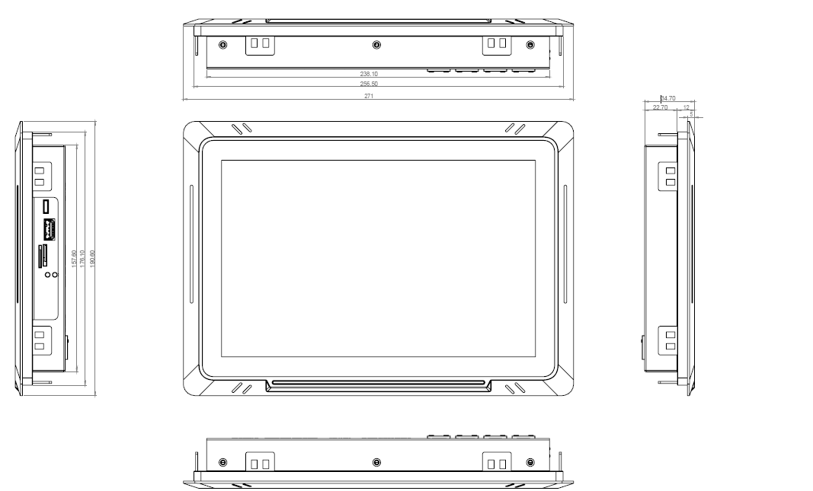

Ⅴ. Pin Definition
Backside Connectors
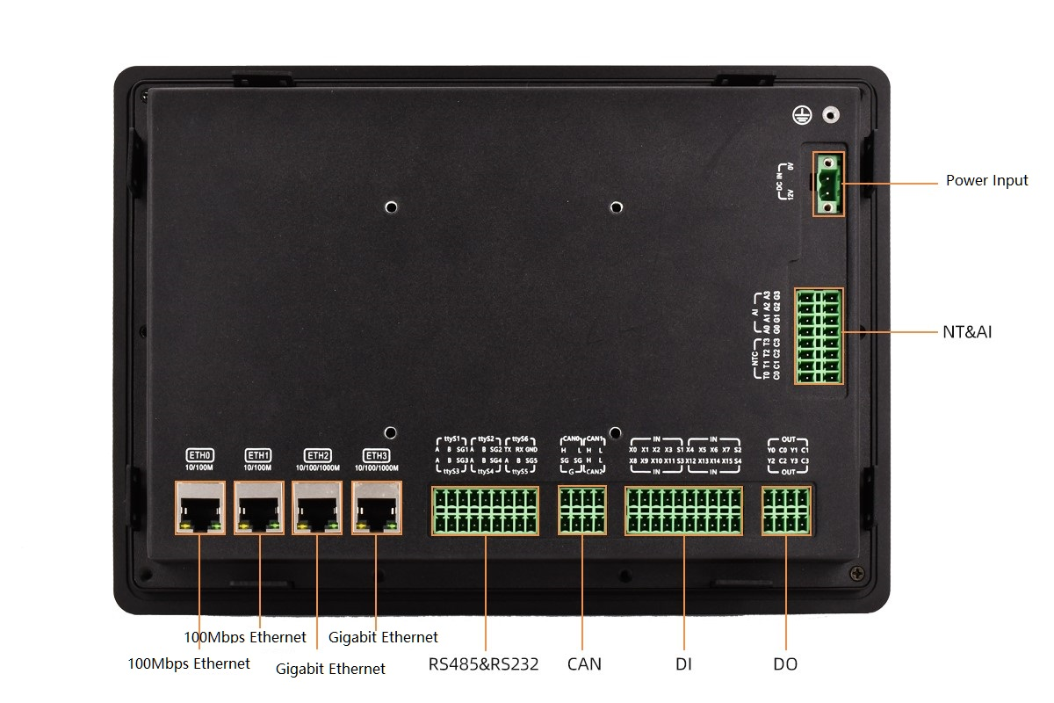

Backside Connectors
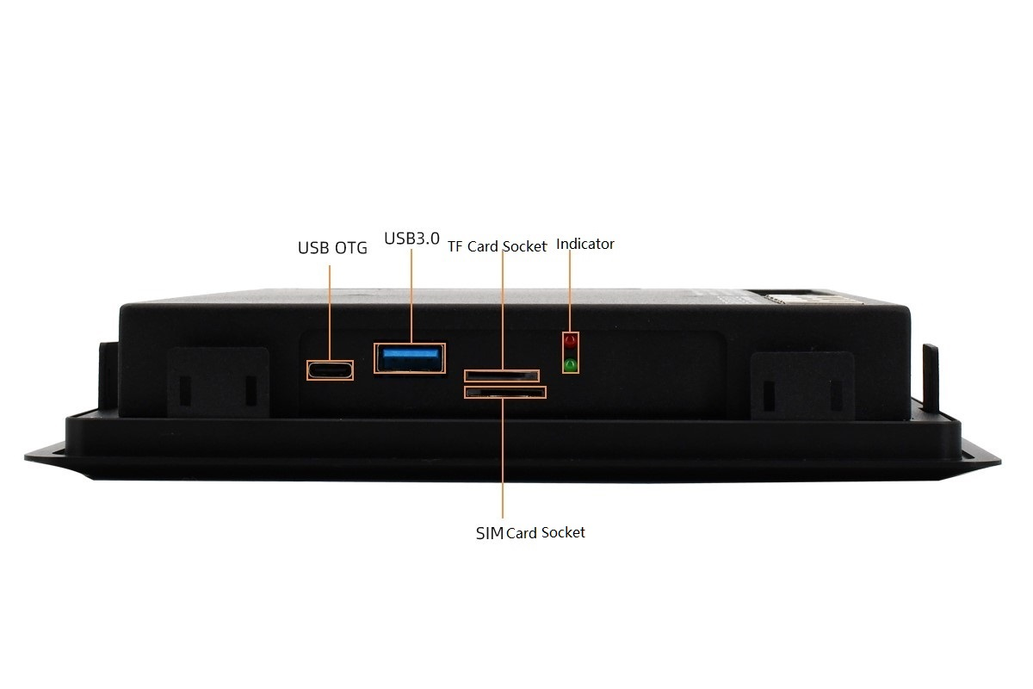

PWR-IN: EDG series-Single Row 2P 5.08MM spacing with screw thread connector
PIN Definition:
# | Pin Definition | Description
1 | PWR_IN | PWR-IN
2 | GND_PWR_IN

RS485&RS232:EDG Series-Double Row 18P 3.81MM spacing connector
PIN Definition:
 | Pin Definition | # | # | Pin Definition
 | RS485_CH1_A | 1 | 2 | RS485_CH2_A
 | RS485_CH1_B | 3 | 4 | RS485_CH2_B
 | SHELL_EARTH | 5 | 6 | SHELL_EARTH
 | RS485_CH3_A | 7 | 8 | RS485_CH4_A
 | RS485_CH3_B | 9 | 10 | RS485_CH4_B
 | SHELL_EARTH | 11 | 12 | SHELL_EARTH
 | COM_RXD | 13 | 14 | RS485_CH6_A
 | COM_RXD | 15 | 16 | RS485_CH6_B
 | GND_ISO_C | 17 | 18 | SHELL_EARTH

CAN:EDG Series-Double Row 8P 3.81MM spacing connector
PIN Definition:
 | Pin Definition | # | # | Pin Definition
 | CAN1_H | 1 | 2 | SHELL_EARTH
 | CAN1_L | 3 | 4 | SHELL_EARTH
 | CAN2_H | 5 | 6 | CAN3_H
 | CAN2_L | 7 | 8 | CAN3_L

DI:EDG Series-Double Row 20P 3.81MM spacing connector
PIN Definition:
 | Pin Definition | # | # | Pin Definition
 | DIN1_1 | 1 | 2 | DIN3_1
 | DIN1_2 | 3 | 4 | DIN3_2
 | DIN1_3 | 5 | 6 | DIN3_3
 | DIN1_4 | 7 | 8 | DIN3_4
 | GND_DIN1_I/F | 9 | 10 | GND_DIN3_I/F
 | DIN2_1 | 11 | 12 | DIN4_1
 | DIN2_2 | 13 | 14 | DIN4_2
 | DIN2_3 | 15 | 16 | DIN4_3
 | DIN2_4 | 17 | 18 | DIN4_4
 | GND_DIN2_I/F | 19 | 20 | GND_DIN4_I/F

D0:EDG Series-Double 8P 3.81MM spacing connector
PIN Definition
 | Pin Definition | # | # | Pin Definition
 | RELAY2_OUT1 | 1 | 2 | RELAY1_OUT1
 | RELAY2_OUT2 | 3 | 4 | RELAY1_OUT2
 | RELAY3_OUT1 | 5 | 6 | RELAY4_OUT1
 | RELAY3_OUT1 | 7 | 8 | RELAY4_OUT1

NTC&AI:EDG Series-Double 16P 3.81MM spacing connector
PIN Definition
 | Pin Definition | # | # | Pin Definition
 | TEMP_NTC4 | 1 | 2 | GND
 | TEMP_NTC3 | 3 | 4 | GND
 | TEMP_NTC2 | 5 | 6 | GND
 | TEMP_NTC1 | 7 | 8 | GND
 | AD4 | 9 | 10 | GND
 | AD3 | 11 | 12 | GND
 | AD2 | 13 | 14 | GND
 | AD1 | 15 | 16 | GND

Ⅵ.Installation Methods
Clip-on Installation:
Installation Illustration:
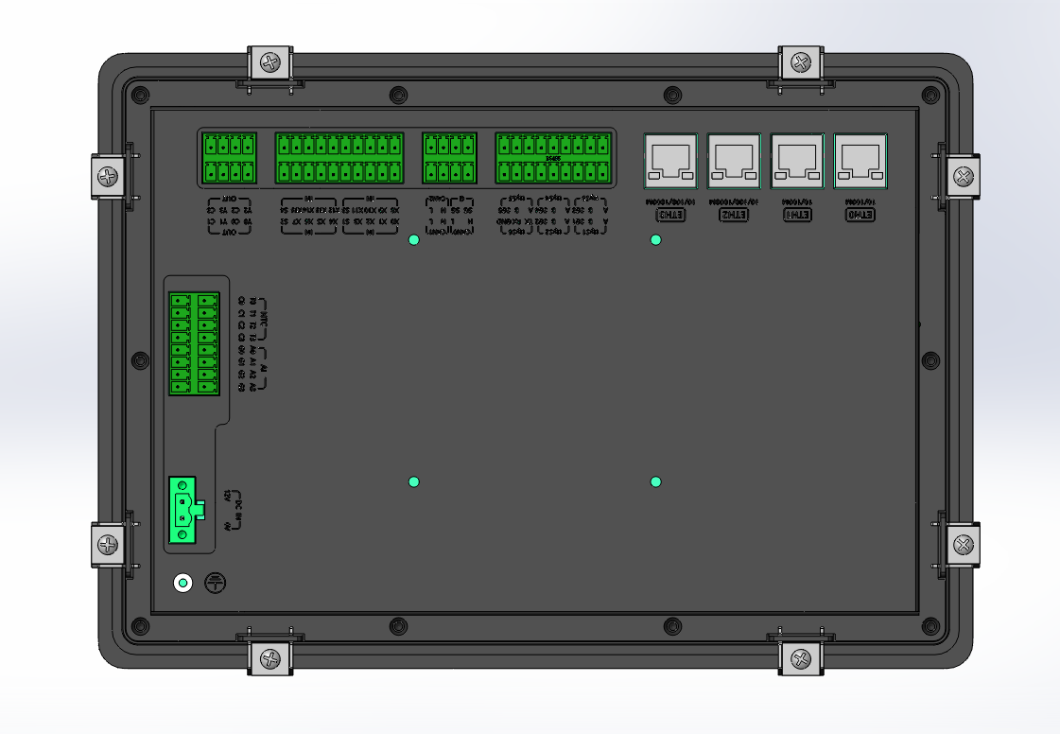
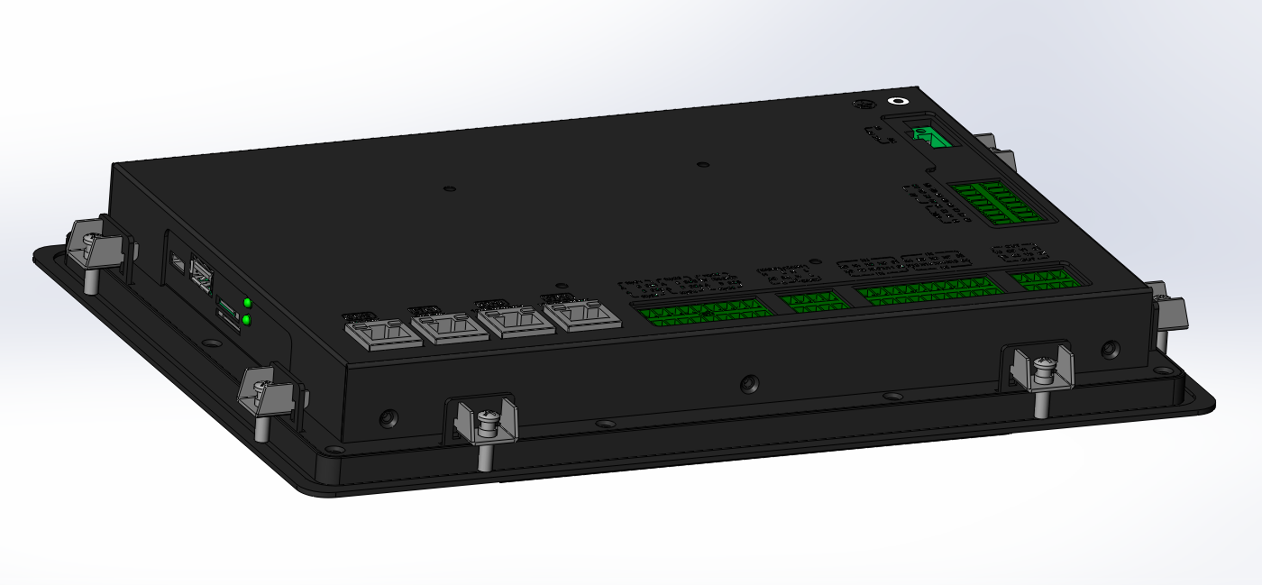

Wall-mounted Installation:

Mounting Hole: International VESA standard:75mm*75mm

Ⅶ. Shipping List
Shipping List
# | Item | Description | Qty | Remark
1 | 10.1 Inch All-In-One Device | QYE101R1B8 | 1
2 | Certificate of Conformance |  | 1
3 | Accessories | Installation accessories, connection terminal | 1
4 | Packaging Carton |  | 1

Configuration
# | Model No. | Description
1 | QYE101R1B8-1N00 | Basic version
2 | QYE101R1B8-1N10 | 4G(CAT4) Module
3 | QYE101R1B8-1N20 | 5G Module

Ⅷ. Cautions
- Please use DC12V±5% or 24V±5% power adapter;

- Adding cover plate on the device is prohibited, it may cause touch failure;

- Applications should avoid writing large amounts of data frequently, to prevent the EMMC storage unit from reaching its lifespan limit and causing the system to fail.

- It is strictly forbidden to disassemble and repair the machine without permission.

Zhejiang Qiyang Intelligent Technology Co.,Ltd

Tel：0571-87858811 / 87858822
Fax：0571-89935912
Technical Support：0571-87858811转805
E-MAIL：supports@qiyangtech.com
Website：http://www.qiytech.com
ADD：3rd Floor, Building A, No.6 West Park 8th Road, West Lake Science and Technology Park, West Lake District, Hangzhou, China
Post Code：310030

